Farhadi, Ramin

ramin.farhadi@lancashire.gov.uk

Abstract

This report strategically outlines Lancashire's internationalisation plan, focusing on Foreign Direct Investment initiatives. Conducting a thorough analysis of Foreign Owned Companies, existing relationships, and global influences, the report identifies key sectors for commissioning detailed propositions. Acknowledging data limitations, the report strives for accuracy and completeness, offering valuable insights for Lancashire's global engagement.



Foreign direct investment report

Internationalisation's FDI pillar

Internationalisation and Foreign Direct Investment (FDI) report

Contents

1. Introduction 2

2. Foreign direct investment and Internationalisation 3

2.1. Foreign owned companies and parent companies: 3

2.2. Industries & Sectors according to SIC codes on Beauhurst: 4

2.3. Key sectors and LEP sectors 5

2.4. Twin towns table 6

2.5. Universities in Lancashire 8

Lancaster University: 8

University of Cumbria: 8

University of Central Lancashire: 9

Edge Hill University: 9

3. Lancashire's activity heat map 10

4. Key findings on target markets and sectors 11

5. Niche sectors categorisation according to Lancashire's supply chain and activities cluster 12

6. Niche sectors based on Memorandum of Understanding (MoU) and Free Trade Agreement (FTA) 12

7. Lancashire's niche sector-target market Boston matrix 14

8. Rational and explanation: 16

9. Limitations 17

10. selected niche sectors for comissioning propositions 17

11. Conclusion 18

References 20

Appendix 23

# Introduction

In the pursuit of our international aspirations, Lancashire has charted a course that exemplifies a strategic vision - an Internationalisation Strategy (LIS) that underscores the region's readiness to compete on a global stage. This strategy reflects our conviction that we possess the assets, capabilities, and prospects necessary to excel in the realms of investment, trade, talent, innovation, and tourism.

This is about Lancashire carving out its own space in the global competitiveness arena and creating a thriving and prosperous society. Measuring our progress through the lenses of international investor appeal, visitor attraction, academic excellence, and foreign direct investment, we seek to drive innovation and enhance productivity. Our focus extends to nurturing an international cultural identity and fostering a thriving business environment that actively engages in global trade.

Lancashire Internationalisation Strategy provides us with a unique opportunity to project our county's natural assets beyond urban centres, positioning Lancashire as a desirable destination for residence, tourism, education, and investment.

In alignment with our internationalisation strategy, this report centres its attention on Foreign Direct Investment, emphasising five distinct actions dedicated to the identification of optimal target markets and niche sectors for the promotion of Lancashire's global prospects. Within the pillar of the Foreign Direct Investment Action Plan, this report delves into Workstream 1 - Leveraging Relationships. We present a detailed account of the actions undertaken within this context, specifically addressing activities and actions 1, 2, and 3 encompassing:

* Mapping the geographical and sectoral distribution of foreign-owned companies in Lancashire.
* Map existing relationships where known of universities, R&D centres and local government twin.
* Cross reference the mapping exercise to see which markets are easiest to access.

The subsequent steps, actions 4 and 5, will be discussed as part of our future initiatives.

Workstream 1 involved a comprehensive effort to map foreign-owned companies operating within Lancashire. Utilising platforms such as Beauhurst and Companies House to identify foreign-owned companies across the Lancashire. This insightful mapping effort extends to understanding the diverse sectors in which these companies operate, offering a rich overview of Lancashire's global economic connections.

As the 2nd action, our data collection extended to universities, R&D centres, and the establishment of twin town relationships. These initiatives not only help us gauge our international engagement but also form essential building blocks for future strategies.

The culmination of these efforts in action 3 allows us to cross-reference the data, revealing the most accessible, promising target markets and niche sectors for Lancashire. We employed the Boston Matrix, considering market size and growth data from various reports, online research, Statista, etc. This analysis incorporates Lancashire's sectors supply chain and global connections to chart our course.

The forthcoming steps in actions 4 and 5 (within workstream 1), will involve engaging with the Department for Business and Trade (DBT) personnel in overseas markets and collaborating with Marketing Lancashire and DBT on ambassador programs designed to promote Lancashire as a prime destination for investment.

This report strives to provide a comprehensive understanding of the Foreign Direct Investment (FDI) action plan and the specific measures undertaken within each action in pursuit of internationalisation goals.

# Foreign direct investment and Internationalisation

Foreign Direct Investment plays a pivotal role in the realisation of our internationalisation strategy. The data underscores Foreign Direct Investment as a crucial driver for Lancashire's global engagement. Foreign Direct Investment not only fosters economic growth but also enables us to forge strong international connections. By attracting and strategically channelling Foreign Direct Investment, we position Lancashire as a prime destination for investment.

## Foreign owned companies and parent companies:

Drawing from data collected through a variety of sources, including Beauhurst and Companies House, our research has unveiled a noteworthy revelation. Within Lancashire, there exist over 600 active companies, each operating as a subsidiary of a grand total of 200 ultimate parent companies, all of which have their headquarters situated outside the United Kingdom. This finding underscores the intricate web of foreign ownership and highlights the global reach and impact of these companies within the Lancashire region.

## Industries & Sectors according to SIC codes on Beauhurst:

The statistics related to SIC code data obtained from Beauhurst reveals a diverse landscape of business sectors in Lancashire, reflecting the region's heritage and economic vibrancy.

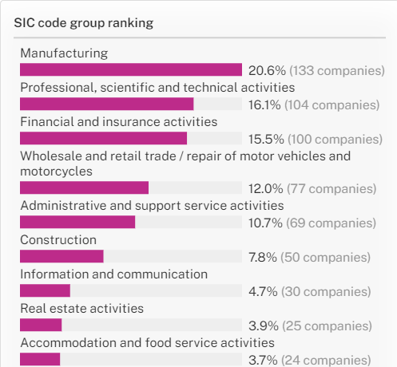

Figure 1: SIC code grouping, Beauhurst.

According to Figure 1, Manufacturing stands out as the predominant sector, representing 20.6% of the companies researched. Following closely are Professional, Scientific, and Technical Activities at 16.1%, and Financial and Insurance Activities at 15.5%. These sectors contribute significantly to the region's economic fabric. Other notable sectors include Wholesale and Retail Trade, Administrative & Support Service Activities, and Construction, each making a substantial impact with 12.0%, 10.7%, and 7.8% respectively. The data underscores the multifaceted nature of Lancashire's business environment, where a range of industries and activities play a role in shaping its economic landscape.

The data presented here also accounts for the intricacies of how companies classify themselves based on their operations. It's essential to note that a single company can be engaged in multiple SIC code groups, aligning with the diverse nature of their business activities. As a result, in the chart above, companies with multiple SIC code groups are counted multiple times, reflecting their involvement in various sectors simultaneously. Consequently, the sum of the percentages across sectors may not necessarily equate to 100% (see full chart in Appendix 1).

## Key sectors and LEP sectors

While the initial insights from Beauhurst statistics provided a valuable overview of the primary sectors in which foreign businesses operate in Lancashire, it was imperative to ensure the reliability of this data. To this end, we conducted a thematic analysis, delving into the descriptions of these businesses to ascertain their actual areas of activity. The results of this in-depth analysis have revealed the top ten sectors that encompass the activities of all 600 foreign-owned businesses in Lancashire, presenting a comprehensive picture of their operational landscape.

These sectors are as follows:

1. Manufacturing
2. Wholesale and Distribution
3. Financial Services
4. Hospitality
5. Retail
6. Environmental Services
7. Healthcare
8. Energy
9. Safety and Security
10. and Technology and Software

Remarkably, a compelling alignment emerges when we compare these sectors with the Lancashire Enterprise Partnership's (LEP) main sectors, which comprise:

1. Advanced Manufacturing
2. Tourism, Culture & Place
3. Food & Agriculture
4. Health
5. Energy & Low Carbon
6. Digital

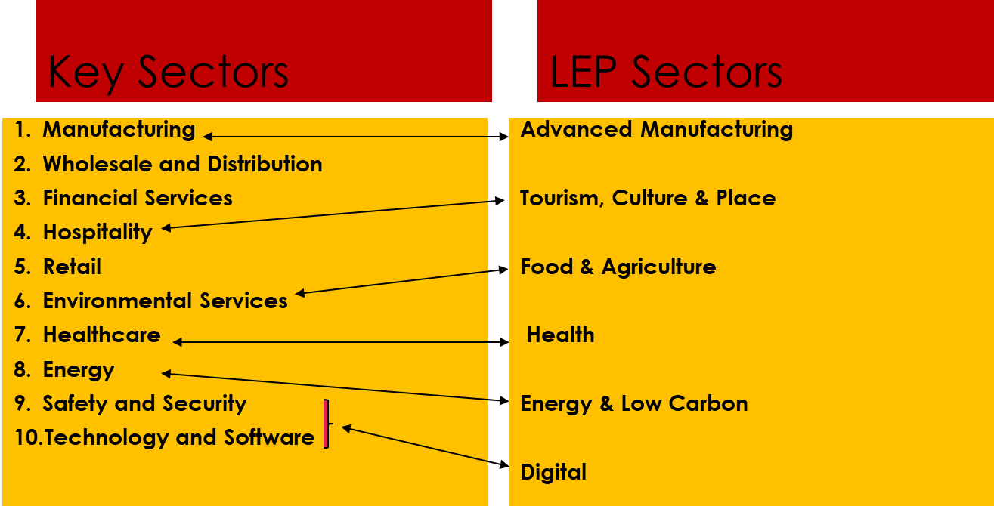Figure 2: Key sectors and LEP sectors

Based on Figure 2, it is evident that the sectors identified within the foreign-owned companies and LEP sectors exhibit a remarkable synergy and compatibility. This congruence not only underscores the cohesiveness of Lancashire's economic landscape but also highlights the potential for strategic collaboration and mutual growth between foreign-owned enterprises and the local enterprise partnership.

## Twin towns table

Twin towns, are cooperative partnerships between two towns or cities, often located in different countries. These connections serve to foster cultural exchanges, enhance mutual understanding, and promote friendship among their citizens. Beyond their cultural and social significance, twin towns can also offer substantial economic benefits. They create opportunities for trade and investment, stimulating economic growth by encouraging businesses and investors to explore and establish connections in their twin town. This can lead to collaborative ventures, international trade, and an influx of Foreign Direct Investment, ultimately contributing to economic development and prosperity for both regions involved.

Table 1: Lancashire's twin town

Table 1 illustrates information regarding Lancashire's affiliations with twin towns situated in diverse countries and continents across the world. While twin towns primarily establish civic connections, it is noteworthy that these relationships can potentially play a pivotal role in supporting Lancashire's Foreign Direct Investment and investment initiatives.

However, Brexit, the withdrawal of the United Kingdom (UK) from the European Union (EU), has had significant implications for Foreign Direct Investment and twin town relationships between the UK and the rest of Europe. The separation has introduced a new economic landscape, impacting investment patterns and collaborative initiatives. Brexit has introduced complexities in the realm of foreign direct investment and twin town relationships between the UK and the rest of Europe. While challenges exist, there is also the potential for the emergence of new opportunities and strategies as both sides navigate the post-Brexit landscape.

## Universities in Lancashire

1. More than 4,000 International students in 2021.
2. Dominant target market of China.
3. Four International Campuses.
4. 90 partners globally.

Lancashire is home to four prestigious international universities, attracting a substantial number of students from around the world. Furthermore, these academic institutions serve as a conduit, facilitating global connections for Lancashire through their extensive international collaborations and partnerships.

### Lancaster University:



### University of Cumbria:

1. Circa 100 International students in 2021.
2. 20 collaborations internationally.
3. 22 partners globally.



### University of Central Lancashire:

1. More than 1,300 international students in 2021.
2. One international campus.
3. Dominant target market of China, India, and Nigeria.
4. 12 partners worldwide.



### Edge Hill University:



1. Circa 33 international students.
2. 62 global partnerships.
3. 860 research collaborations.

# Lancashire's activity heat map

By considering all the endeavours within Lancashire, including foreign-owned businesses, twin town partnerships, and the international initiatives of its universities, we have successfully developed a heatmap.

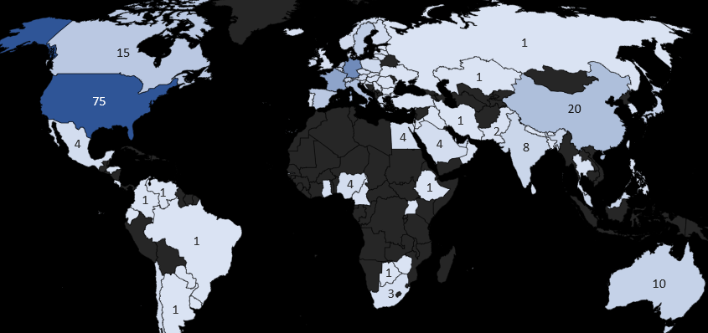Figure 3: Lancashire's international activity heatmap

Figure 3 illustrates the regions of the world where Lancashire has significant connections and demonstrates heightened activity.

These target markets may find Lancashire appealing enough to increase their investments or to grow their companies here. This heat map shows that Lancashire's connections and activity are primarily concentrated in the USA, Germany, France, Netherlands, Canada, and India. These nations may be appealing when marketing Lancashire as the top location for business and investment.

# Key findings on target markets and sectors

We can classify the top target markets and industries as follows based on all the data that has been gathered from various sources:

The following list of top 10 target markets for Lancashire is based on the findings (we can take into account criteria like the existence of several firms in a nation, economic stability, and market potential).

1. Netherlands
2. Belgium.
3. Japan
4. Switzerland.
5. Ireland.
6. United States.
7. Germany.
8. France.
9. Canada.
10. India.

Target markets

And these are the Key Sectors that are predominant in the specified target markets:

Numerous businesses listed are engaged in the production of a wide range of goods, such as PVC foils, silicone products, automotive components, aircraft structures, and more. Subsequently, businesses involved in the distribution and wholesale of goods including toys, pet-related products, and promotional goods comprise our second largest industry. Following that, a sizeable portion of foreign-owned businesses are financial planning and wealth management corporations. And yet a more sizable portion of the energy industry is made up of businesses that provide fuel monitoring services and renewable energy solutions. Additionally: businesses that offer industrial control equipment, internet platforms, and software services. There are certain businesses that operate the hospitality and leisure industry that are represented by luxurious lodgings and theme parks. Finally, there are number of foreign owned companies which are active in the health service sector.

Top sectors

1. Advanced manufacturing.
2. Wholesale and distribution.
3. Financial Services.
4. Energy.
5. Technology and Software
6. Hospitality
7. Health Services

We performed thematic analyses on all foreign-owned firms' recorded descriptions to discover related niche sectors for all companies. After analysing, we were able to identify important themes and key terms to use as key niche sectors.

# Niche sectors categorisation according to Lancashire's supply chain and activities cluster

Relying on the Lancashire's Enterprise Zones including Blackpool Airport, Hillhouse, Samlesbury, Warton, and Lancashire's supply chain in specific niche sectors we managed to draw Lancashire's Cluster table (Target Market- Niche Sector table).

Table 2: Lancashire's Cluster (Target Market- Niche Sector)

Remember that in Table 2 niche sectors and key markets are chosen based on Lancashire's supply chain cluster, its activities, and its global leverage. In addition, we divided the target markets into two groups:

1. Core markets, which are simpler to enter and have less restrictions on FDI, commerce, and business; and

2. Emerging markets, where there may be more obstacles to commercial partnerships.

# Niche sectors based on Memorandum of Understanding (MoU) and Free Trade Agreement (FTA)

Although the Lancashire Cluster table helps us visualise potential target markets and niche sectors to promote Lancashire, to target the industries and markets where business negotiations are most likely to occur, we needed a deeper understanding of the UK's Free Trade Agreements (FTA) and Memorandums of Understanding (MoUs).

We have utilised the FTAs and MoUs to determine which markets and industries are more supportive of our plans and in line with our FDI initiatives. We thus created the MoUs & FTAs table:

Table 3: MoUs & FTAs (Target Market- Niche Sector)

While Table 3 represent data on niche sectors- target market based on MoUs and FTAs, we went one step further to improve the accuracy of our findings and make them consistent with Lancashire's internationalisation strategies:

Table 4: Mutual sectors (Target Market- Niche Sector)

In Table 4, we combined the data and identified the mutual target markets and sectors in order to make our conclusions consistent with the Lancashire cluster as well as MoUs and FTAs.

It is vital to note that each sector's importance is measured using stars, where three stars represent the most important niche sectors.

# Lancashire's niche sector-target market Boston matrix

Next, we wanted to focus our efforts and resources in the proper areas, so we prioritised Lancashire's target markets and specialty industries using a Boston matrix tool to determine where we should promote Lancashire the most and first.

The Boston Matrix is a valuable strategic tool that classifies a company's portfolio of products, businesses, or markets into four distinct categories: Question Marks, Stars, Cash Cows, and Dogs. We investigated every report that was available on the potential sizes and growth of the markets in Lancashire's designated target areas in order to create this Boston matrix (Appendix 2).

In the development of this Boston Matrix, thorough consideration has been given to Lancashire's specialised industry sectors, their supply chain dynamics, and their global network of connections which are available in Table 4.

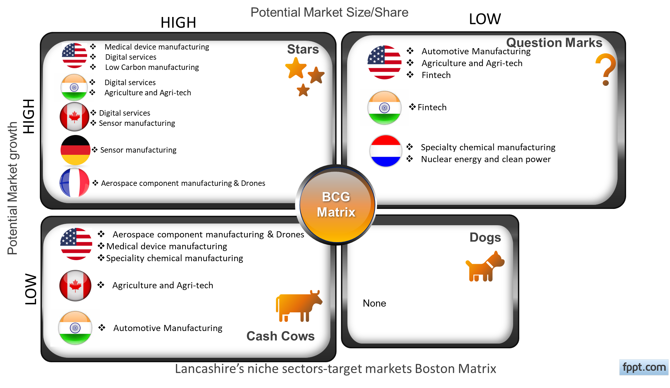

15

Figure 4: Lancashire's niche sectors-target markets Boston matrix.

Figure 4 illustrates Lancashire's niche sector-target market Boston matrix. To create this matrix, we have categorized market growth rates as either high or low. Market size is categorized based on the unit of currency, with millions considered low and billions or trillions considered high.

• High Growth: Market growth rates greater than 10%

• Low Growth: Market growth rates less than 10%

• Low Market Size: Market size in millions

• High Market Size: Market size in billions or trillions

It is essential to highlight that, in our pursuit of a streamlined set of proposals, we prioritize focusing on markets that exhibit the most favourable projections in terms of both market growth and market size. Consequently, certain sectors, such as agriculture and agri-tech in France, which demonstrate a negative growth rate, have been omitted from our target markets. Although Lancashire maintains business relationships with companies from these countries, the adverse market growth outlook may deter potential investments in the county. Furthermore, the proposals formulated for more promising markets can also be applied to benefit these sectors.

# Rational and explanation:

As previously mentioned, we utilised Lancashire's clustering method, market size, and market growth within various niche sectors to construct a Boston Matrix. Notably, Table 4 highlights our emphasis on target markets, categorizing them into Core and Emerging markets. In the subsequent step, we factored in the available potential market size and market growth to develop our Boston Matrix. We have to mention that in the context of emerging markets, the "Question Marks" or "Problem Children" category is often associated with emerging markets. These are target markets-niche sectors with a low current market share but operating in a high-growth market. The term "Question Marks" suggests that their future is uncertain – they could become stars or cash cows if their market share increases, or they may decline if they don't gain market share.

16

Emerging markets often have high growth potential, but they also come with higher uncertainties and risks. Companies need to invest resources in these markets to capture opportunities and build market share. If successful, these Question Marks can evolve into Stars or Cash Cows over time.

# Limitations

We exerted utmost effort to ensure the accuracy and comprehensiveness of this report; nevertheless, certain limitations beyond our control need acknowledgment. Foremost among these is the potential influence of human error in data transfer or entry, particularly in instances involving platforms like Beauhurst. To mitigate this risk, we diligently cross-referenced information from various sources to validate our data.

Secondly, some data presented in the report is outdated. Despite our efforts to access more recent information, certain datasets, such as the number of international students in universities, are constrained by their availability, with the latest figures only extending to the year 2021. Despite these limitations, we have strived to present the most accurate and reliable information within our means.

# selected niche sectors for comissioning propositions

Based on the insights derived from Figure 4, which illustrates the Boston Matrix, and the comprehensive data provided in Table 4, our team has strategically identified propositions to advance. These propositions, carefully chosen for their promising potential, are as follows:

1. Nuclear Energy and Clean Power
2. Digital Services
3. Low Carbon Manufacturing
4. Medical Device Manufacturing
5. Aerospace Component Manufacturing & Drones

It's worth noting that these niche sectors have been recognized as high-importance areas and have been categorized as either Core or Emerging markets in different target markets, as indicated by the Boston Matrix presented in Figure 4.

Additionally, contingent on budgetary considerations, there is a possibility of commissioning Agriculture & Agri-tech, given its notable presence with three stars in Table 4. This strategic selection is grounded in a thorough analysis of the market dynamics and the positioning of these sectors within the Boston Matrix framework and Lancashire's cluster.

# Conclusion

As a crucial element of Lancashire's internationalisation strategy, this report places a central focus on the Foreign Direct Investment plan, encompassing five distinct actions. In accordance with the first action, the report meticulously presents information regarding Foreign Owned Companies in Lancashire, detailing their geographical distribution and sectors. Lancashire boasts over 600 foreign-owned companies, with more than 200 parent companies overseeing these subsidiaries.

The subsequent step involves providing data on established relationships, where identifiable, with universities, R&D centres, and twin towns. The report delves into the myriad activities undertaken by Lancashire and identifies the continents and regions where Lancashire holds significant influence.

In the third action, the report conducts a cross-reference of the mapping exercise and gathered information to discern the markets that are most accessible. This analysis considers various factors, including Lancashire's supply chain cluster, market size, and growth across diverse sectors and markets. Additionally, the report factors in the Memorandum of Understanding between the UK and various states in the USA, as well as Free Trade Agreements globally, to construct a Boston Matrix. This matrix serves as a strategic tool, guiding the focus and initiatives of Lancashire.

After a comprehensive consideration of all factors, the Lancashire Enterprise Partnership team has decided to commission propositions in key sectors, namely Nuclear Energy and Clean Power, Digital Services, Low Carbon Manufacturing, Medical Device Manufacturing, Aerospace Component Manufacturing & Drones, and Agri-Tech.

The next steps involve establishing contact with personnel from the Department for Business and Trade (DBT) in three overseas markets aligned with Lancashire's goals. Finally, collaboration with Marketing Lancashire and DBT on their ambassador programs will be undertaken, aimed at promoting Lancashire as an attractive investment destination.

# References

Anon, (n.d.). *Lancashire Enterprise Zones – Samlesbury Aerospace Enterprise Zone*. [online] Available at: https://samlesburyez.com/lancashire-advanced-manufacturing-and-energy-cluster/ [Accessed 9 Nov. 2023].

Beauhurst. (n.d.). *Discover the UK’s Fast-Growing Companies*. [online] Available at: https://www.beauhurst.com/.

Council, L.C. (n.d.). *Lancashire Advanced Manufacturing and Energy Cluster*. [online] Lancashire.gov.uk. Available at: https://www.lancashire.gov.uk/council/transparency/access-to-information/service-and-project-specific-privacy-notices/lancashire-advanced-manufacturing-and-energy-cluster/ [Accessed 9 Nov. 2023].

Council, R.V.B. (n.d.). *Lancashire Advanced Engineering and Manufacturing Enterprise Zone Local development Order documents*. [online] Ribble Valley Borough Council. Available at: https://www.ribblevalley.gov.uk/downloads/download/313/lancashire-advanced-engineering-and-manufacturing-enterprise-zone-local-development-order-documents [Accessed 9 Nov. 2023].

Foreign Direct Investment Action Plan 2022 -2025 2. (n.d.).

GOV.UK. (n.d.). *Memorandum of understanding (MOU) on cooperation and trade relations between the US state of North Carolina and the United Kingdom*. [online] Available at: https://www.gov.uk/government/publications/uk-and-north-carolina-co-operation-and-trade-memorandum-of-understanding/memorandum-of-understanding-mou-on-cooperation-and-trade-relations-between-the-us-state-of-north-carolina-and-the-united-kingdom [Accessed 9 Nov. 2023].

GOV.UK. (n.d.). *Memorandum of understanding (MOU) on cooperation and trade relations between the US state of South Carolina and the United Kingdom*. [online] Available at: https://www.gov.uk/government/publications/uk-and-south-carolina-co-operation-and-trade-memorandum-of-understanding/memorandum-of-understanding-mou-on-cooperation-and-trade-relations-between-the-us-state-of-south-carolina-and-the-united-kingdom [Accessed 9 Nov. 2023].

GOV.UK. (n.d.). *Memorandum of Understanding on economic cooperation and trade relations between Indiana and the United Kingdom*. [online] Available at: https://www.gov.uk/government/publications/uk-and-indiana-trade-and-economic-memorandum-of-understanding/memorandum-of-understanding-on-economic-cooperation-and-trade-relations-between-indiana-and-the-united-kingdom [Accessed 9 Nov. 2023].

GOV.UK. (n.d.). *Memorandum of Understanding on economic cooperation and trade relations between the US state of Oklahoma and the United Kingdom*. [online] Available at: https://www.gov.uk/government/publications/uk-and-oklahoma-co-operation-and-trade-memorandum-of-understanding/memorandum-of-understanding-on-economic-cooperation-and-trade-relations-between-the-us-state-of-oklahoma-and-the-united-kingdom [Accessed 9 Nov. 2023].

GOV.UK. (n.d.). *Memorandum of Understanding on economic cooperation and trade relations between the US state of Utah and the United Kingdom*. [online] Available at: https://www.gov.uk/government/publications/uk-and-utah-trade-and-economic-cooperation-memorandum-of-understanding/memorandum-of-understanding-on-economic-cooperation-and-trade-relations-between-the-us-state-of-utah-and-and-the-united-kingdom [Accessed 9 Nov. 2023].

GOV.UK. (n.d.). *Memorandum of Understanding on trade co-operation, innovation and clean energy between the Washington State and the United Kingdom*. [online] Available at: https://www.gov.uk/government/publications/uk-and-washington-state-trade-cooperation-innovation-and-clean-energy-memorandum-of-understanding/memorandum-of-understanding-on-trade-co-operation-innovation-and-clean-energy-between-the-washington-state-and-the-united-kingdom [Accessed 9 Nov. 2023].

GOV.UK. (n.d.). *UK/EU and EAEC: Trade and Cooperation Agreement [TS No.8/2021]*. [online] Available at: https://www.gov.uk/government/publications/ukeu-and-eaec-trade-and-cooperation-agreement-ts-no82021.

Invest in Lancashire. (n.d.). *The Enterprise Zones*. [online] Available at: https://investinlancashire.com/enterprise-zones/ [Accessed 9 Nov. 2023].

Inward-Investment-Prospectus. (n.d.).

Lancashire Enterprise Partnership. (n.d.). *LAMEC*. [online] Available at: https://lancashirelep.co.uk/key-initiatives/lamec/.

Opencorporates.com. (n.d.). *OpenCorporates*. [online] Available at: https://opencorporates.com/.

platform.beauhurst.com. (n.d.). *Log In - Beauhurst*. [online] Available at: https://platform.beauhurst.com/search/advancedsearch/eetbzr [Accessed 6 Nov. 2023].

South Ribble Borough Council. (n.d.). *Lancashire Enterprise Zone*. [online] Available at: https://www.southribble.gov.uk/article/1148/Lancashire-Enterprise-Zone [Accessed 9 Nov. 2023].

Statista. (n.d.). *Autonomous & Sensor Technology - Germany | Market Forecast*. [online] Available at: https://www.statista.com/outlook/tmo/artificial-intelligence/autonomous-sensor-technology/germany#:~:text=The%20market%20size%20in%20the [Accessed 30 Oct. 2023].

UK-Canada Free Trade Agreement: The UK’s Strategic Approach. (n.d.).

UK-India Free Trade Agreement: The UK’s Strategic Approach. (n.d.).

UK-US Free Trade Negotioation. (n.d.).

www.futuremarketinsights.com. (n.d.). *Technical Textiles Market*. [online] Available at: https://www.futuremarketinsights.com/reports/technical-textiles-market [Accessed 30 Oct. 2023].

www.precedenceresearch.com. (n.d.). *Medical Devices Market Size, Growth Report, Trends, 2022-2030*. [online] Available at: https://www.precedenceresearch.com/medical-devices-market#:~:text=U.S.%20medical%20devices%20market%20size.

# Appendix

Appendix 1: sectors SIC code percentage.

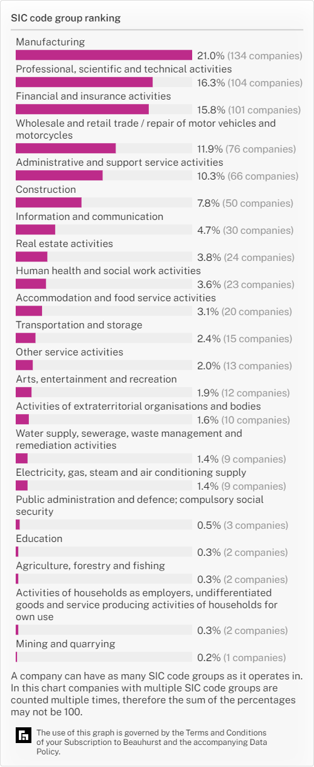

Appendix 2: market growth and market size (note: we convert some measures to unify the outcomes)

